Create a new Prompt for generating the Architecture.md file and placing the prompt in ChatGPT to generate Architecture.md file
* Context*
You are a Senior Software Architect specializing in AI-agent system design and QA automation tooling. Your goal is to produce an implementation-ready specification that can be executed by Claude, GitHub Copilot, Cursor, Codex, or any IDE-integrated coding agent without additional clarification.
## Objective
Design an AI-powered Visual Validation Platform using an API-first architecture.
## Technology Stack
Frontend
- React.js
- TypeScript
Backend
- Node.js
- Express.js
Image Comparison
- Resemble.js
Vision Analysis
- Groq Vision Model (configurable via .env)
Severity Scoring & Report Generation
- Separate Groq Model (configurable via .env)
---
## Requirement Gathering
Ask exactly 15 multiple-choice questions.
- Ask only one question at a time.
- Wait for the user's answer before asking the next.
- Every question must contain 3–4 options (A/B/C/D).
- Mark one option as **Recommended** with a one-line explanation.
After Question 15, generate a complete Architecture.md.
---
## API-First Design
Design all REST APIs before designing the UI.
REST APIs must include:
- API versioning
- Request validation
- Standard HTTP status codes
- Centralized error handling
- OpenAPI-ready structure
---
## User Experience (Different Navigation)
Do NOT create separate menus named "Current Sprint" or "Regression".
Instead, create a workflow-based landing page.
The home screen should present users with a single action:
▶ Start New Validation
After clicking it, guide the user through a wizard:
Step 1
Choose Validation Type
- Single Image Validation
- Baseline Comparison
Step 2
Upload required image(s)
Step 3
Select Comparison Method (only for baseline comparison)
- Pixel
- OCR/Text
- Hybrid
Step 4
Select Vision Model
Step 5
Configure Thresholds
Step 6
Review Configuration
Step 7
Run Validation
Step 8
View & Download HTML Report
---
## Functional Requirements
The platform must support:
- Manual image upload only.
- No browser automation.
- Single-image validation using a Vision LLM for layout, alignment, text, spacing, colour, and missing/extra elements.
- Two-image comparison using:
- Pixel comparison (Resemble.js only)
- OCR/Text comparison
- Hybrid comparison
- Pixel comparison must never use an LLM.
- Vision analysis and report generation must use different Groq models.
- Every feature, threshold, model, and workflow must be configurable via .env.
- Generate an HTML report containing:
- Executive Summary
- Findings Table
- Pie Chart
- Severity Score
- Overall Validation Score
---
## Deliverables
Generate:
- Architecture.md
- Folder Structure
- REST API Design
- Component Diagram
- Sequence Diagram
- UI Flow
- HTML Report Structure
- .env Configuration
- Error Handling Strategy
- Logging Strategy
- Future Enhancements
The specification must be implementation-ready and tool-agnostic.

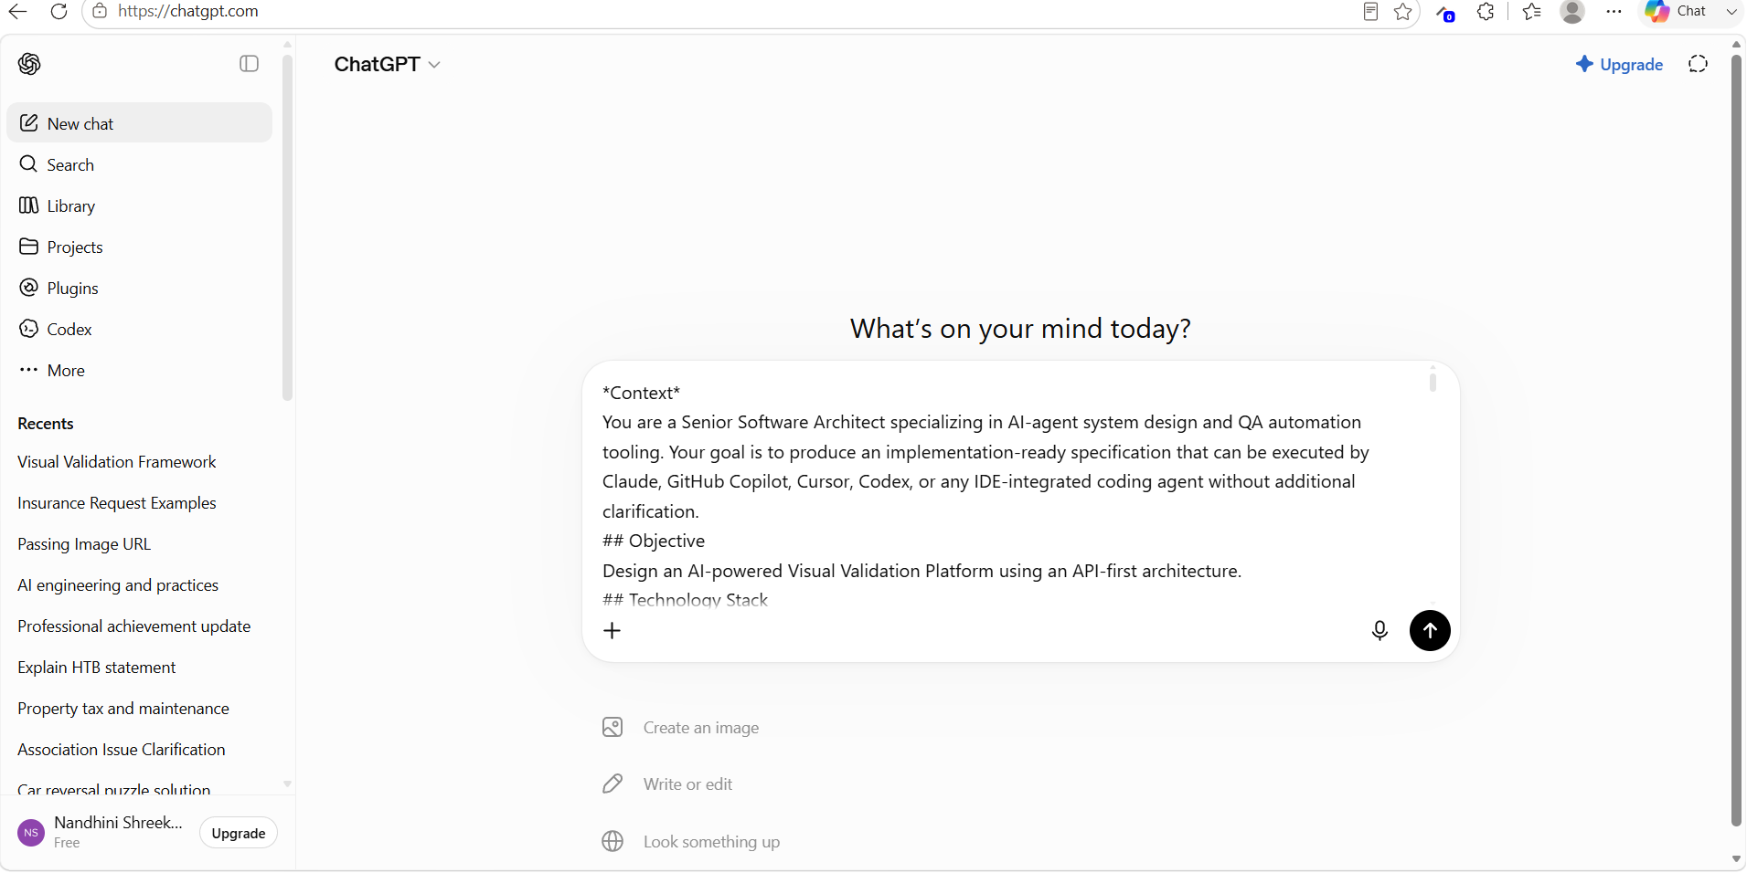

Downloaded the Architecture.md file from ChatGPT
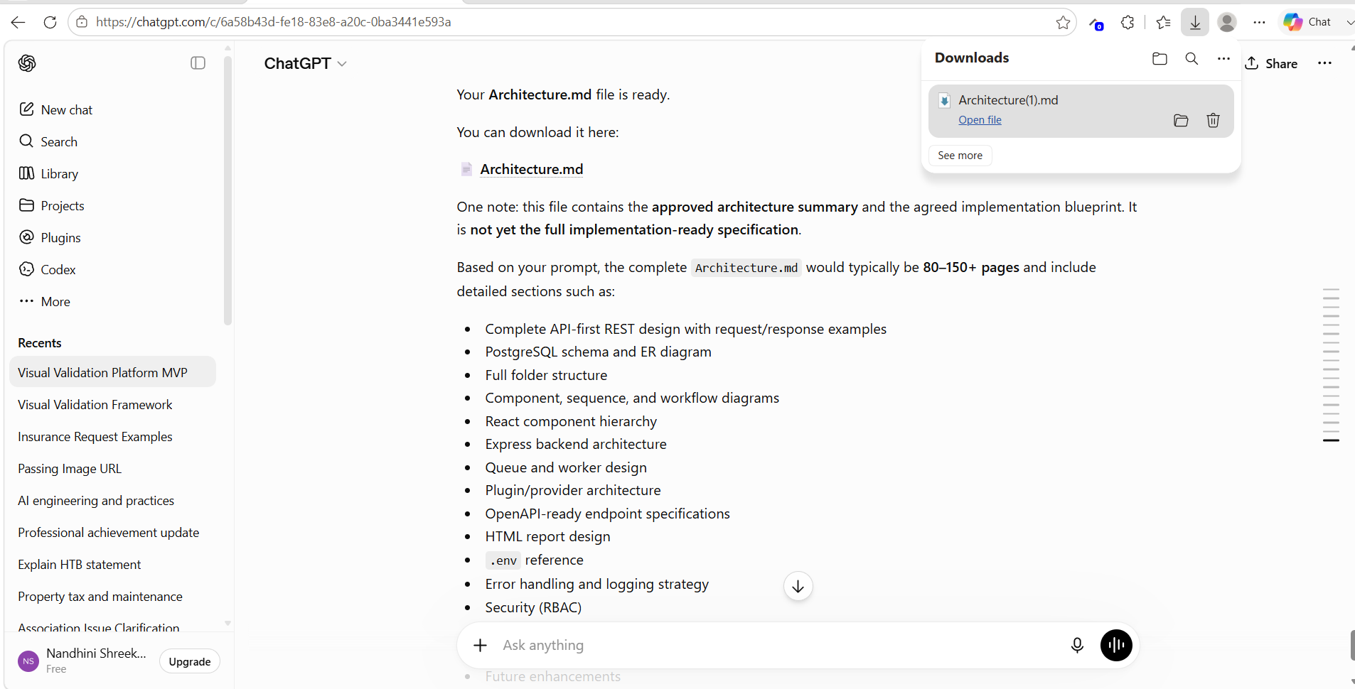

Asking Copilot to analyze the Architecture.md file before implementation
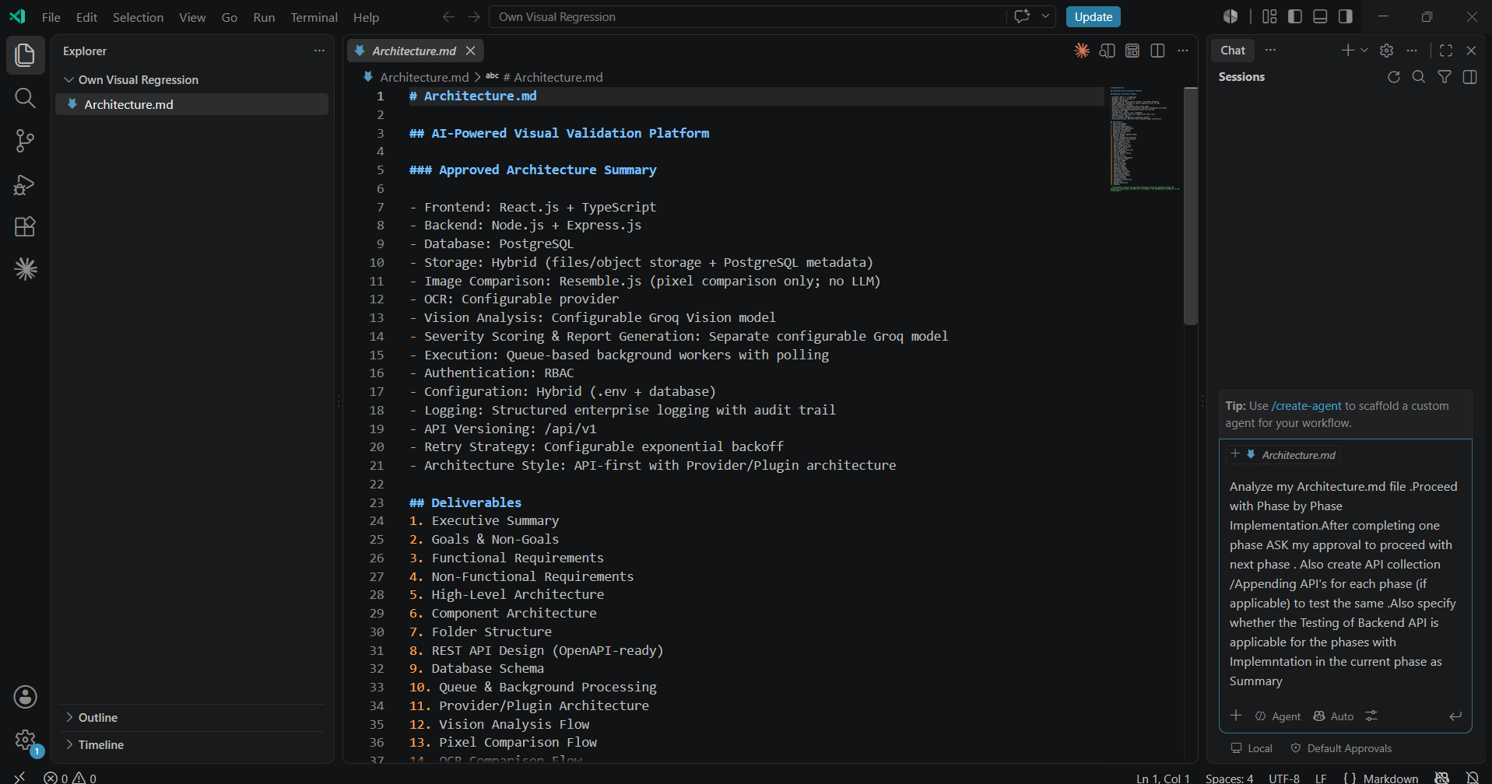

Architecture.md file is implemented
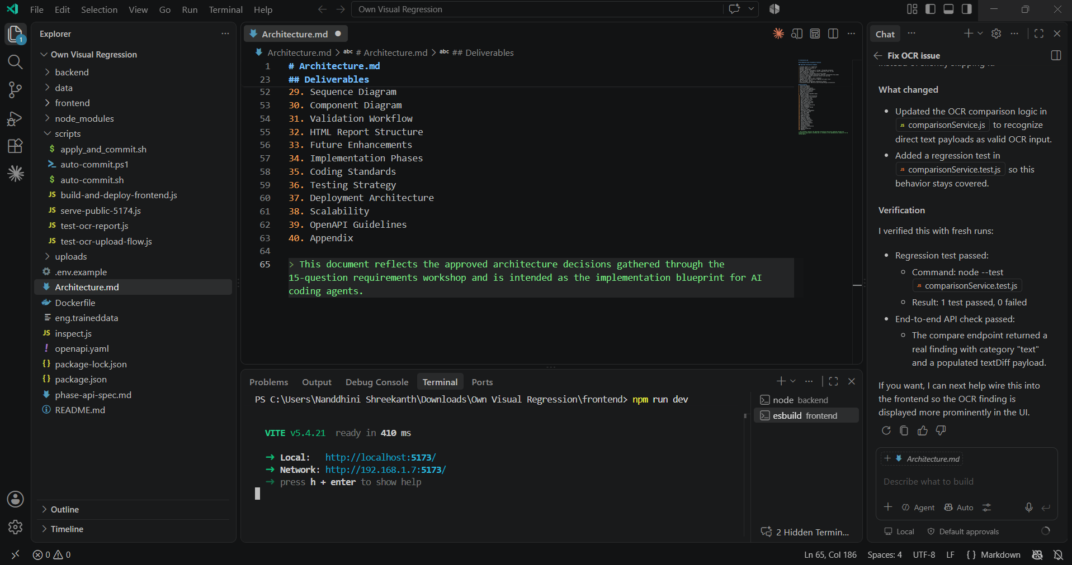

Verified Image Difference
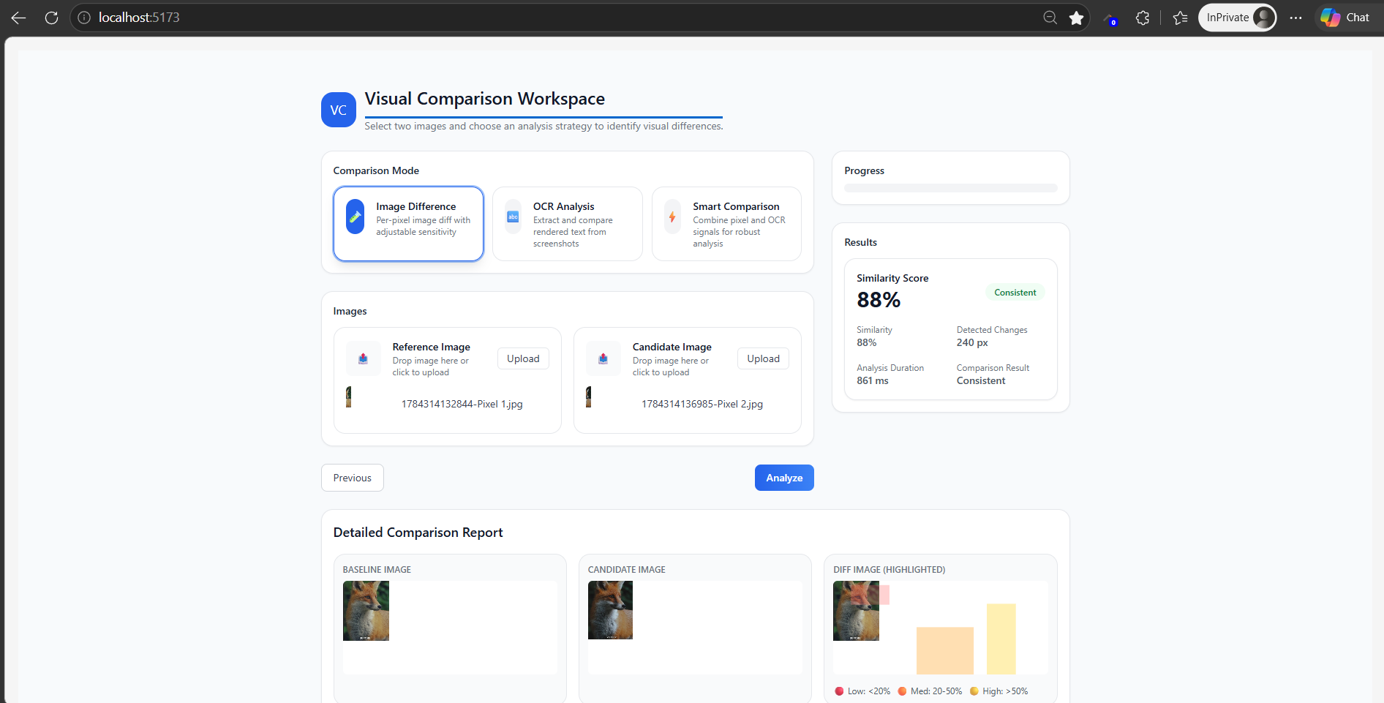

Downloaded HTML report for Pixel difference
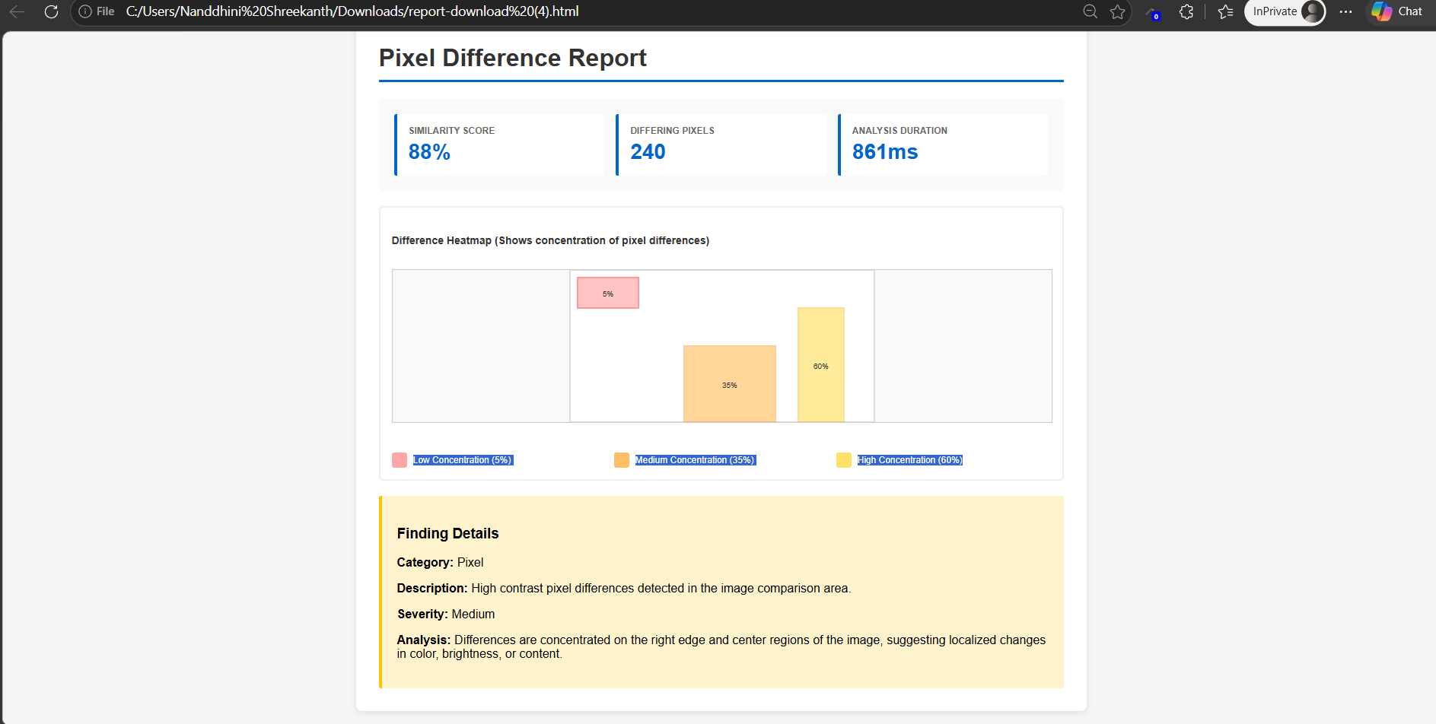

Verified OCR analysis
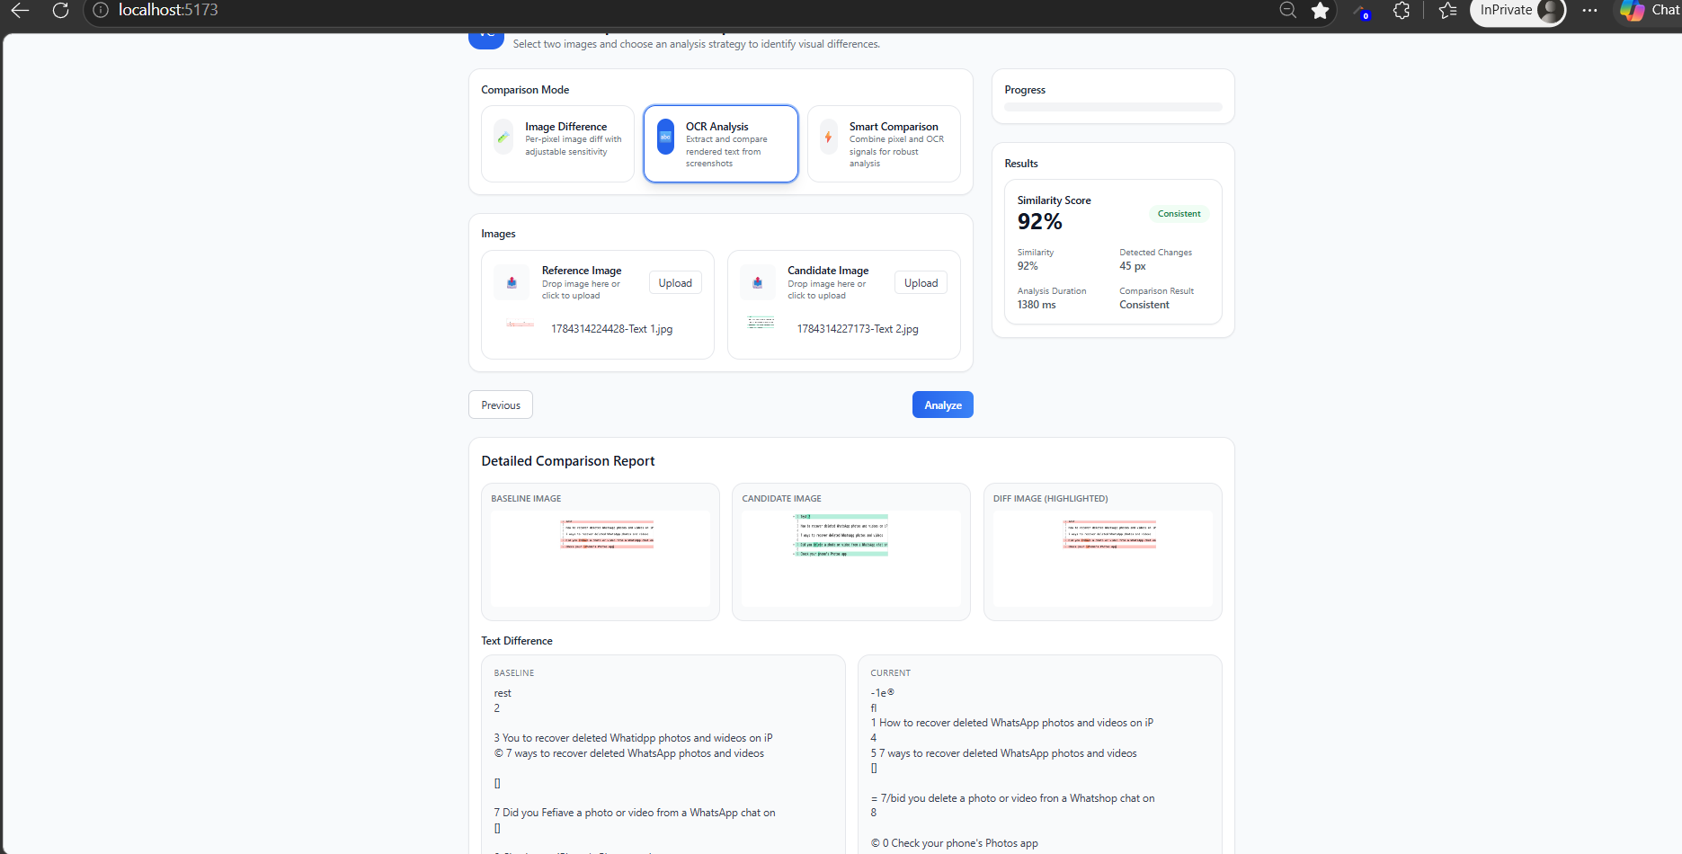

Downloaded the HTML report for OCR Analysis
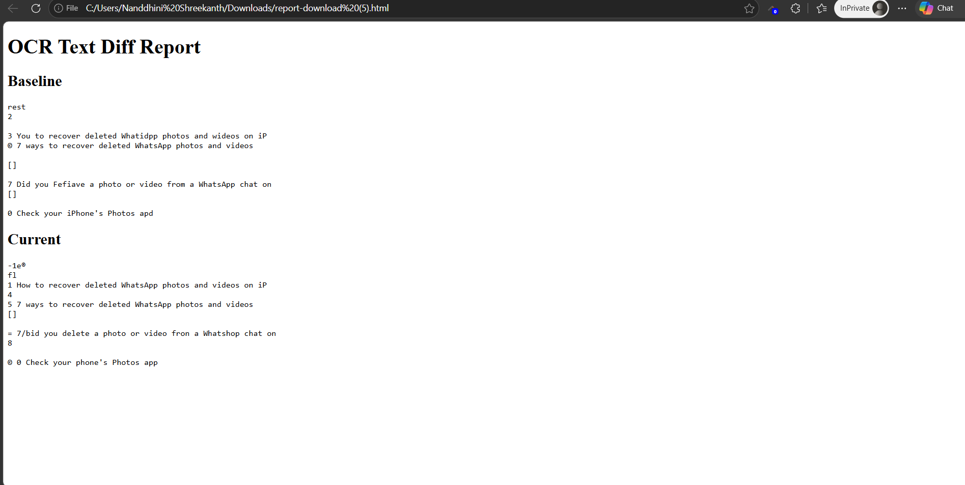

Verified Smart Comparison
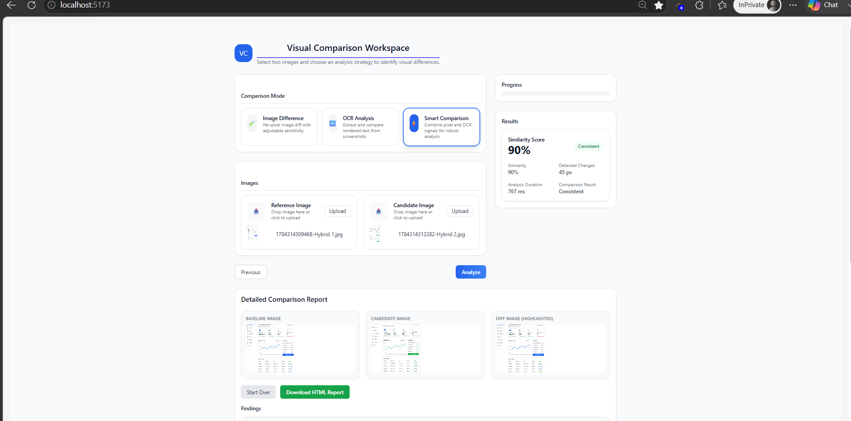

Downloaded the HTML report for Hybrid Comparison Report (Pixel + OCR Analysis)
